Unit 5 Practice Test: Functions

1. Let *f* be a function such that *f*(*x*)= 5*x* − 4 is defined on the domain 1 ≤ *x* ≤ 6.
2. Identify the range for this function
3. 1 ≤ *f*(*x*) ≤ 6 3. −∞ ≤ *f*(*x*) ≤ 26
4. 26 ≤ *f*(*x*) ≤ 1 4. 1 ≤ *f*(*x*) ≤ 26
5. Which statement is always true about this function?

$1. f\left(x\right)<0$ $3. if x<1, f\left(x\right)<0$

$2. f\left(x\right)>0$ $4. if x>1, f\left(x\right)<0$

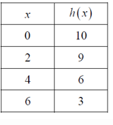2) Answer the following questions for the table below

a. f(0)=_______________ b. x when f(x) is = 6:_____________

c. Rate of change from x=2 to x=6: _______________

e. If included in the table, which ordered pair, (-2, 12) or (2, -12), would result in a relation that is no longer a function? Explain your answer.

1. Evaluate each expression below given that  and 

Use two different ways to show the answer:

1. $f(-3)$ b. $g(4)=$
2. Samantha is babysitting during weekends. She charges 3 dollars initial fees and 5 dollars for every hour she babysits. Using the function E(h) = 5h + 3 will determine how much M-Money Samantha makes for working h-hours. (6 pts)
   1. Calculate and Interpret E(10)
   2. Samantha is babysitting to buy an I-phone case that she likes, the case is $118.Determine how many hours Samantha would need to work in order to buy the case.
3. Consider the following piecewise function given by the formula
$$f\left(x\right)=\left\{\begin{aligned}1-2x -4≤x≤-1 \\ x^{2} -1<x≤3\end{aligned}\right.$$

4. Evaluate $f\left(-1\right)=$
5. Identify all x values for which $f(x)=9$
6. A cell phone company charges $30 dollars a month for 800 text messages or less. If a family text more 800 messages and up to 1200 messages, the company charges $50. If they text more than 1200 messages and up to 1800 messages, the bill jumps to $80. This scenario can be presented by a function for which x is the number of text messages and f(x) is the cost at the end of the month.
   * 1. Graph this function on the provided grid.
     2. 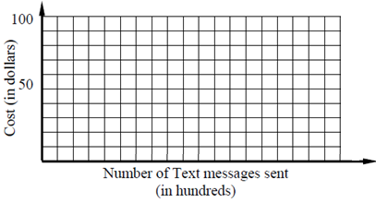How much would you have to pay if you used:

500 text messages ____________

1700 text messages ____________

* + 1. Interpret *f* (1400, 80).
    2. Identify the domain and range.

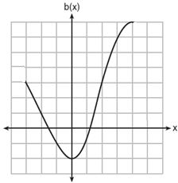

1. The accompanying graph is a sketch of the function *y* = f(*x*)
2. Identify the domain.
3. Identify the range.
4. Evaluate $f\left(-1\right)=$
5. Identify the y intercept.
6. Identify the Maximum the Minimum.
7. Find the Average rate of change from $x=-2$ to $x=2$

**Review Questions:**

* + 1. Which expression is equal to (*x* + 3)2?

1. *x*2 + 6
2. *x*2 + 9
3. *x*2 + 6*x* + 9
4. *x*2 + 3*x* + 9
   * 1. Solve for *x*:  6(*x* − 2) − 4*x* = 16
5. 2 3.   7
6. 12 4.   14
   * 1. Which value of *x* is in the solution set of the inequality −2*x* + 5 > 17?
7. −8 3. −6
8. −4 4. 12
   * 1. 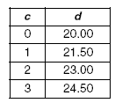Which linear equation represents the data in the accompanying table?
9. *d* = 1.50*c*
10. *d* = 1.50*c* + 20.00
11. *d* = 20.00*c* + 1.50
12. *d* = 21.50*c*
    * 1. What is the value of the *y-*coordinate of the solution to the system of equations 2*x* + *y* = 8 and *x* − 3*y* = −3?
13. −2 3. 2
14. 3 4. −3
    * 1. 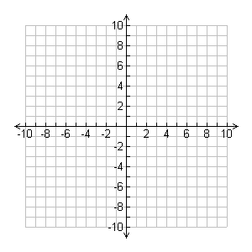Which point is in the solution set of the following system of inequalities?

*y* < 2*x* + 1  
*y* ≥ –https://www.castlelearning.com/Review/Courses/integratedalgebra/1-3.gif?v=20060518053250*x* + 4

1. (5, 0)
2. (6, 6)
3. (−2, 1)
4. (1, 9)
   * 1. Find the value of if
5. -1 3.   9
6. 7 4. 11
   * 1. Which sentence illustrates the associative property?
        + 1. *xy* = *yx* 3.   *x*(*yz*) = (*xy*)*z*
          2. *x*(*y* + *z*) = *xy* + *xz* 4.   1(*xy*) = *xy*
     2. Subtract 5x2 + 2x – 11 from 3x2 + 8x – 7.
        1. 2x2 + 10x – 17 3. 8x2 + 10x – 17
        2. 2x2-6x – 4 4. -2x2 + 6x + 4
7. 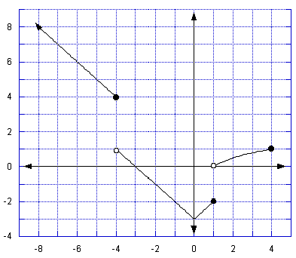A. What is the range of the graph below?
8. [0, 1] and [4, ∞)
9. [-3, 1] and [4, ∞)
10. [-3, 1) and (4, ∞)
11. [-3, ∞)

B. What is the minimum?

1. 3

2. 4.